A2 Report
  - IFQ715 Web Development
  - Christopher Horsfall

Introduction
‘World Happiness Survey’ is a React-based web application that allows users to view data from a database via a REST API. The API as 3 endpoints; GET/rankings, GET/countries, and GET/factors/(year). The web application only uses GET/factors/(year) and GET/rankings.

Use of endpoints

The web-app is structured around 4 pages: Home, Factors, Login, and Register.
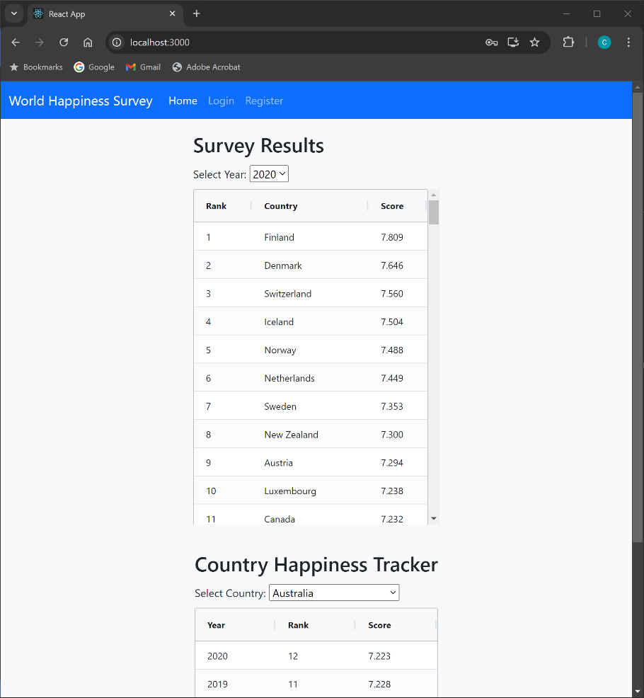
Figure 1 Home Screen
Home screen displays 2 components: ‘Survey Results’ and ‘Country Happiness Tracker’. Both these components utilise the GET/rankings API endpoint, but they use different query parameters to filter the data.
‘Survey Results’ uses the ‘year’ query parameter to display the happiness rankings and score for all countries in a selected year.
‘Country Happiness Tracker’ uses the ‘country’ query parameter to display the happiness ranking and score of a selected country through the years the survey was conducted.
By using AG-grid-react, the tables used to display the data can have their data entries sorted by the column properties.
The 2 components were design to answer two questions that were deemed answerable by the GET/Rankings endpoint:
- What is ‘x’ country’s happiness score/rank and does it compare to other countries in the same survey?
- How as ‘x’ country’s happiness score/rank changed over time?
It was concluded that these questions could be answered by a AG-grid-react table and the GET/rankings endpoint.
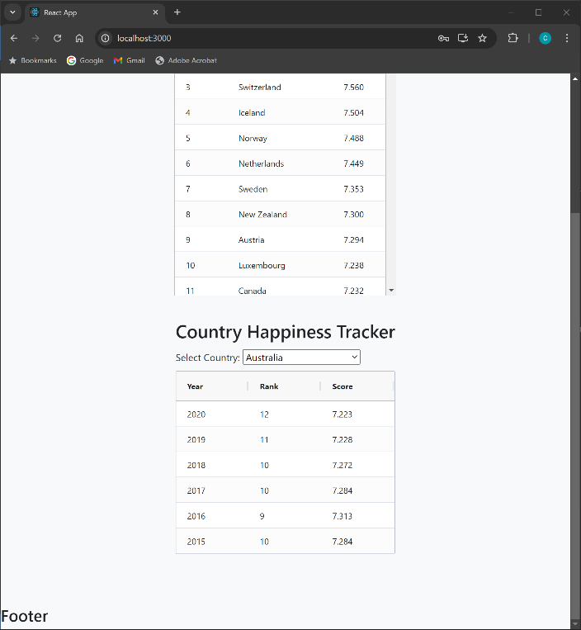
Figure 2 Home screen 'Country Happiness Tracker'

Factors Page
The endpoint GET/Factors/(year) requires the user to be authenticated. This is done via a valid JWT token in the request header. Because of this ‘Factors’ is its own separate page in the app. This page is hidden from the user until they login.
Once the user has logged in they can click the ‘Factors’ page to proceed there.
For the purpose of debugging a valid login credential has been supplied.
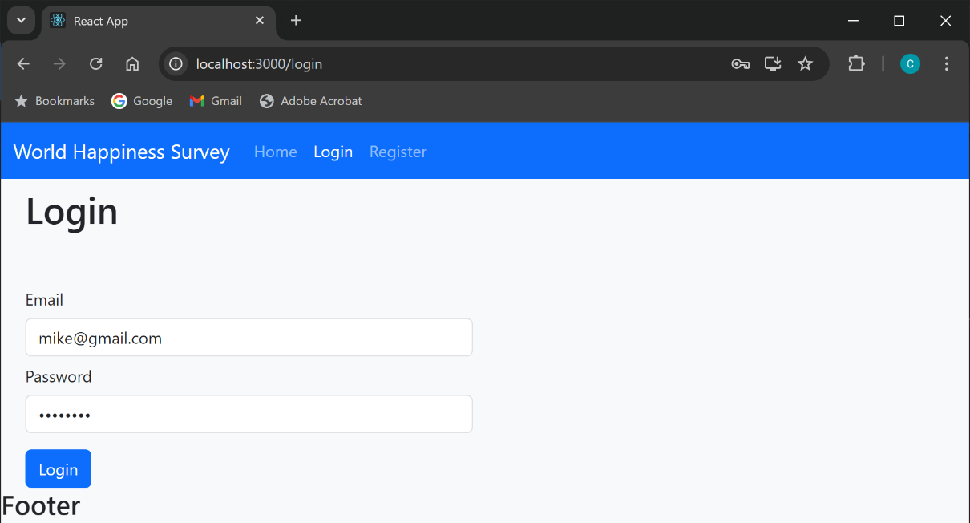
Figure 3 Login with valid credentials
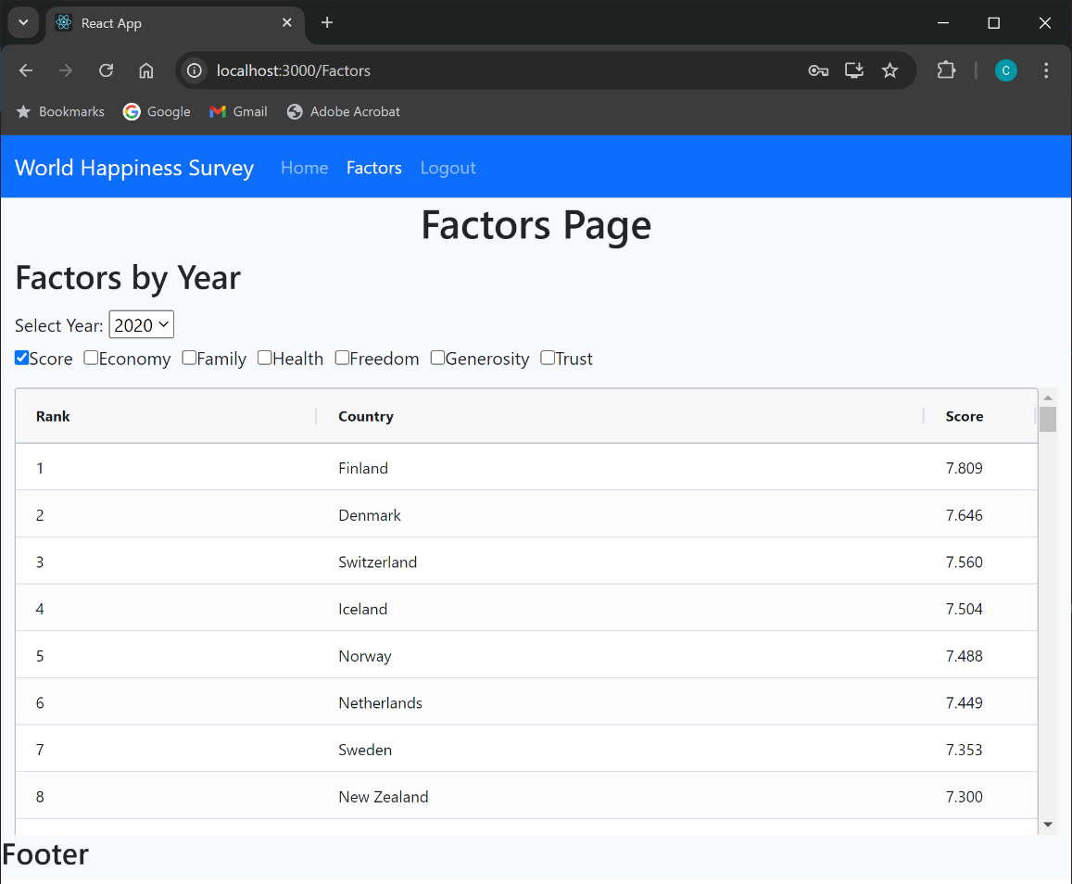
Figure 4 Factors Page default selection

The endpoint GET/Factors/(year) supplies a lot of data for a list of countries in a given year. It was decided that there would be too much data to display in a table all at once, especially if the user was using the app on a small device, like tablet or smartphone.
A row of radio buttons is provided to allow the user to dynamically select what data properties they wish to display. The AG-grid-react table allows the user to sort the data by column.
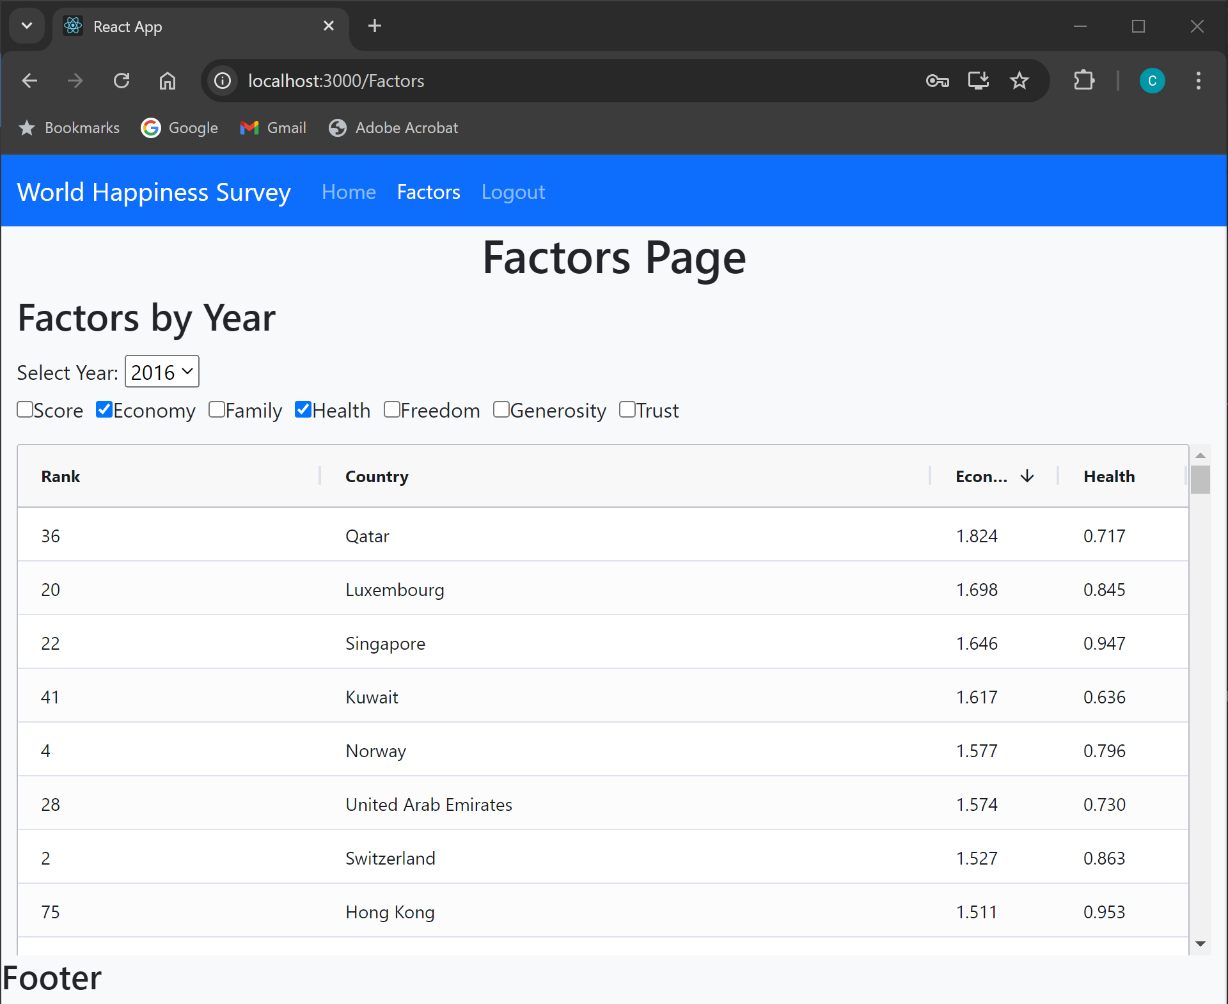
Figure 5 Factors for year 2016, showing Economy and Health, ordered by Economy
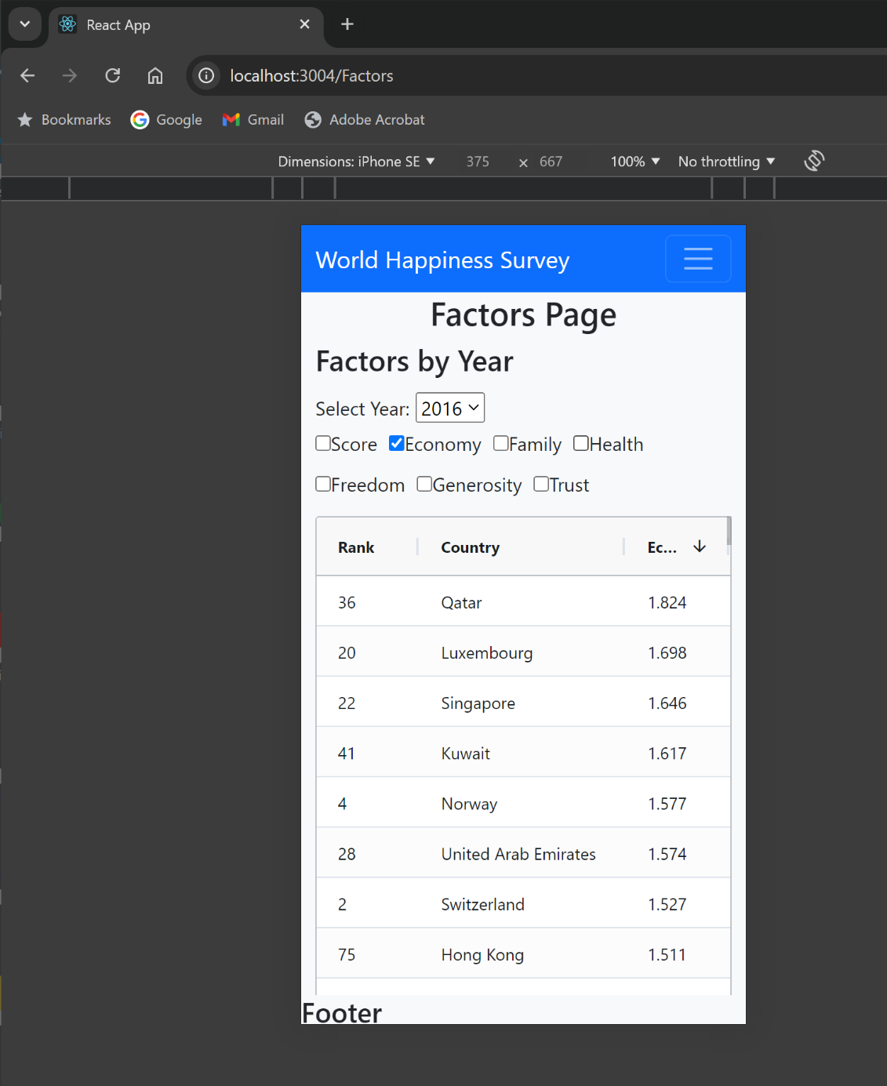
Figure 6 Factors Page on iPhone, showing limited screen space
The API endpoint GET/countries was not used as it didn’t provide any information the user might request. The endpoints’ output of a list of countries was used to populate the country selector drop-down in the ‘Country Happiness Tracker’.

External Components
AG-Grid-react was used, see: https://www.ag-grid.com/

Technical Description

Architecture
The app is structured as a single-page application using the React library.
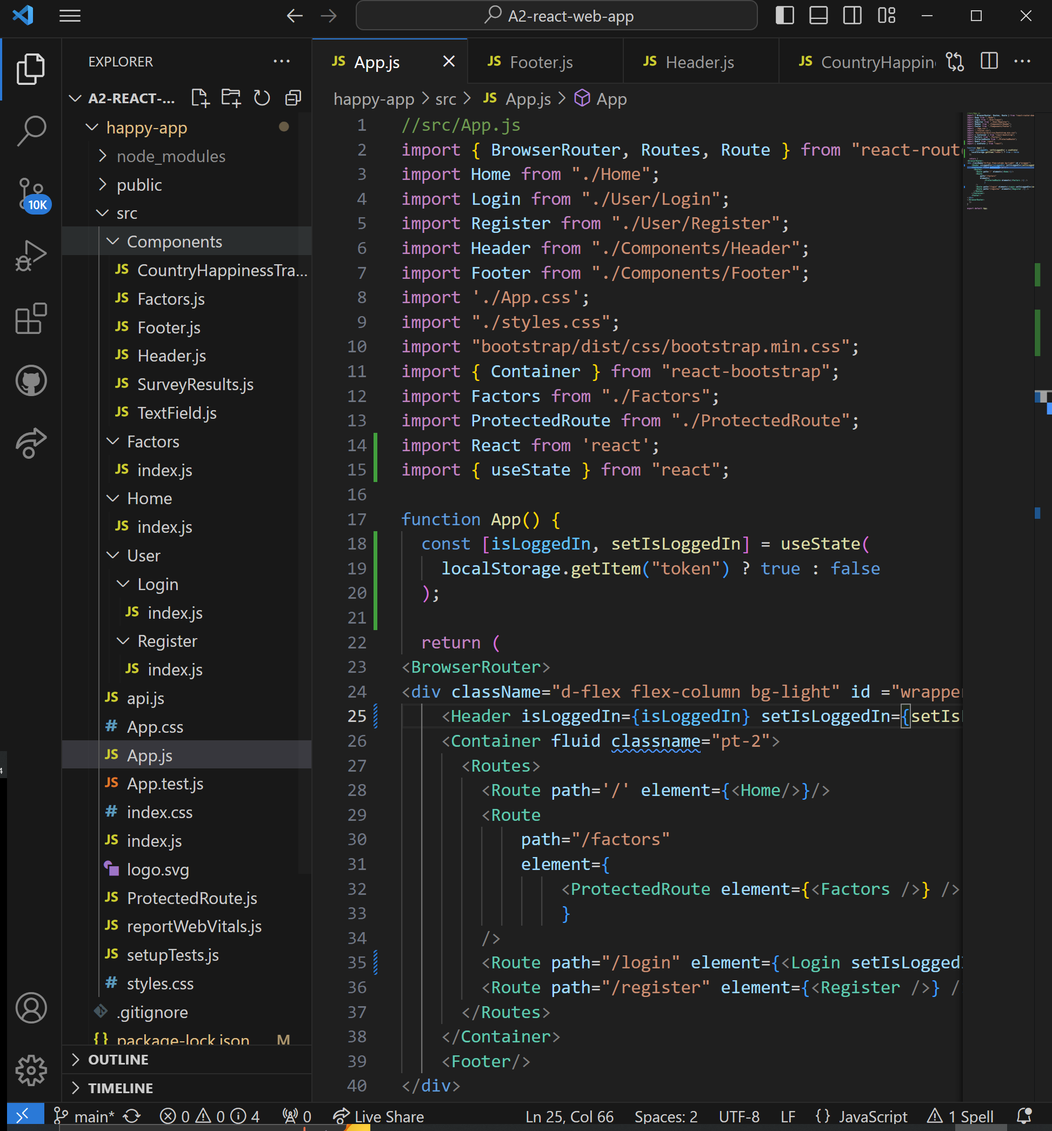
Figure 7 App file structure and file App.js

Routing with React Router is used to navigate between the pages of the web-app.
The app is organized into several components, each responsible for a specific function within the user interface. Three components display data via the API with custom hooks.
Figure 8 Components and their Hooks and Fetch functions
Component | Custom Hook | Fetch function
CountryHappinessTracker.js | useRankings(year) | getRankings(year)
Factors.js | useCountryData(country) | getCountryData(country)
SurveyResults.js | useFactorsData(year) | getFactors(year)

Hooks manage state, including error states using React’s useState and useEffect.
Upon mounting or when a selector/button state changes (like the year drop down) a fetch request to the API is triggered.
Fetch functions construct the API request including any necessary headers like API-Keys or Bearer tokens.
Login and Register pages and functions contain their own fetch requests.

Test Plan and Results

Test | Result
Start App | pass
View home page | pass
Test year selector under Survey Results | pass
Test ‘order by columns’ for table under Survey Results | pass
Test scroll on table | pass
View Country Happiness Tracker | pass
Test country selector | pass
Test ‘order by columns’ for table under Country Happiness Tracker | pass
Test scroll on table | pass
View Home page under different screen sizes, tablet and iPhone | pass
Test Login | pass
Go to Factors page | pass
Test year selector | pass
Test radio buttons | pass
Test ‘order by columns’ | pass
View Factors page under different screen sizes, tablet and iPhone. | pass
Test Logout | pass
Test Register | pass

Limitations and Compromises

Problem | Possible Solution
Switching between Factors and Home page reloads data from the API; No data is stored between page changes | Store fetched data
No quick way of searching for the Factors of a specific country; have to order country column alphabetically and scroll down. | Add a second component to the Factors page that operates similarly to the ‘Country Happiness Tracker’. Use GET/Factors API. Use multiple requests, one for each year with country value constant.  Should be able to compare happiness factors for a single country over time.
UI and aesthetics look unfinished or unprofessional.  - Lots of space wasted on larger screen sizes.  - Aesthetics don’t match the theme of ‘World Happiness Survey’  - Footer Section empty  - Sometimes column header titles get cropped unnecessarily | - Add pictures of happy people from around the world.  - Experiment with ‘Happy’ colour pallets (maybe yellow)  - Add details and acknowledgments to footer.  - Experiment more with CSS styling to allow space for headers

Where to go for version 2:
When viewing complicated data such as the World Happiness Surveys, the limit to what can be shown clearly with tables has been reached.
Charts and other graphical methods of viewing data should be explored to improve the web app.
AG Charts has many chart categories to use as templates.
Information with a time component is usually best displayed with line graphs, with time being shown on the x axis.
How the happiness of certain countries has changed over time, as a total score or with respect to different factors, can be shown with line and stacked area charts.
Since the API only has 5 time entries a decision should be made one whether bar charts would show timeseries data better.
A chart that shows the total and component factors of a specific nations’ happiness score variation over time should be include in future versions of the app.
When considering what chart is suited to this project we should consider what questions the user might like to ask of the data.

Questions to ask data | Possible App Response
“Has the world become happier over time?” | Use data from GET/Rankings API. Sum the total score from all countries for each survey year. Create new country entry ‘World’. Display ‘World’ happiness statistics.
“Which countries have improved the most in their Happiness”? | Use data from GET/Rankings API. Find the difference in score from the 2020 survey and 2015 survey for each country. Find the country with the largest positive difference.
“Are their regions on Earth that are happy/unhappy?” | Display data on a world heat map chart.
“What is the most important factor contributing to happiness in each country?” | Use data from GET/Factors API. For each entry find the factor with the largest value. Display result on coloured world map or in table.

Adding features to the app so that it can answer such questions, and more, will help improve the app immensely and showcase the value of the data.

References
AG Grid. (n.d.). AG Grid: The best JavaScript grid in the world. AG Grid. https://www.ag-grid.com/

Appendix
User guide:
Home page:
Survey Results:
Use the drop-down selector to select the year a survey was conducted.
Click on any column header (Rank, Country, Score) to order the data by that property. Click again to reverse order.
Country Happiness Tracker:
Use the drop-down selector to select the country.
Click on any column header (Rank, Year, Score) to order the data by that property. Click again to reverse order.
Login or Register and Login to view Factors page.
Factors page.
Use the drop-down selector to select the year a survey was conducted.
Click to check any one or more of the factors options. (Score, Economy, Family, Health, Freedom, Generosity, Trust). The data for that factor will be added to the table.
Click on any column header to order the by that property. Click again to reverse order.
Logout
Click logout in the nav bar to log out.

